Inclined Plane
# Source: AI Source: Provided by: [Data Path: Persons Table -> ID Column: 1, Name_En Column: Motasem Essam] -> From: [ChatGPT] on [7/25/2026]
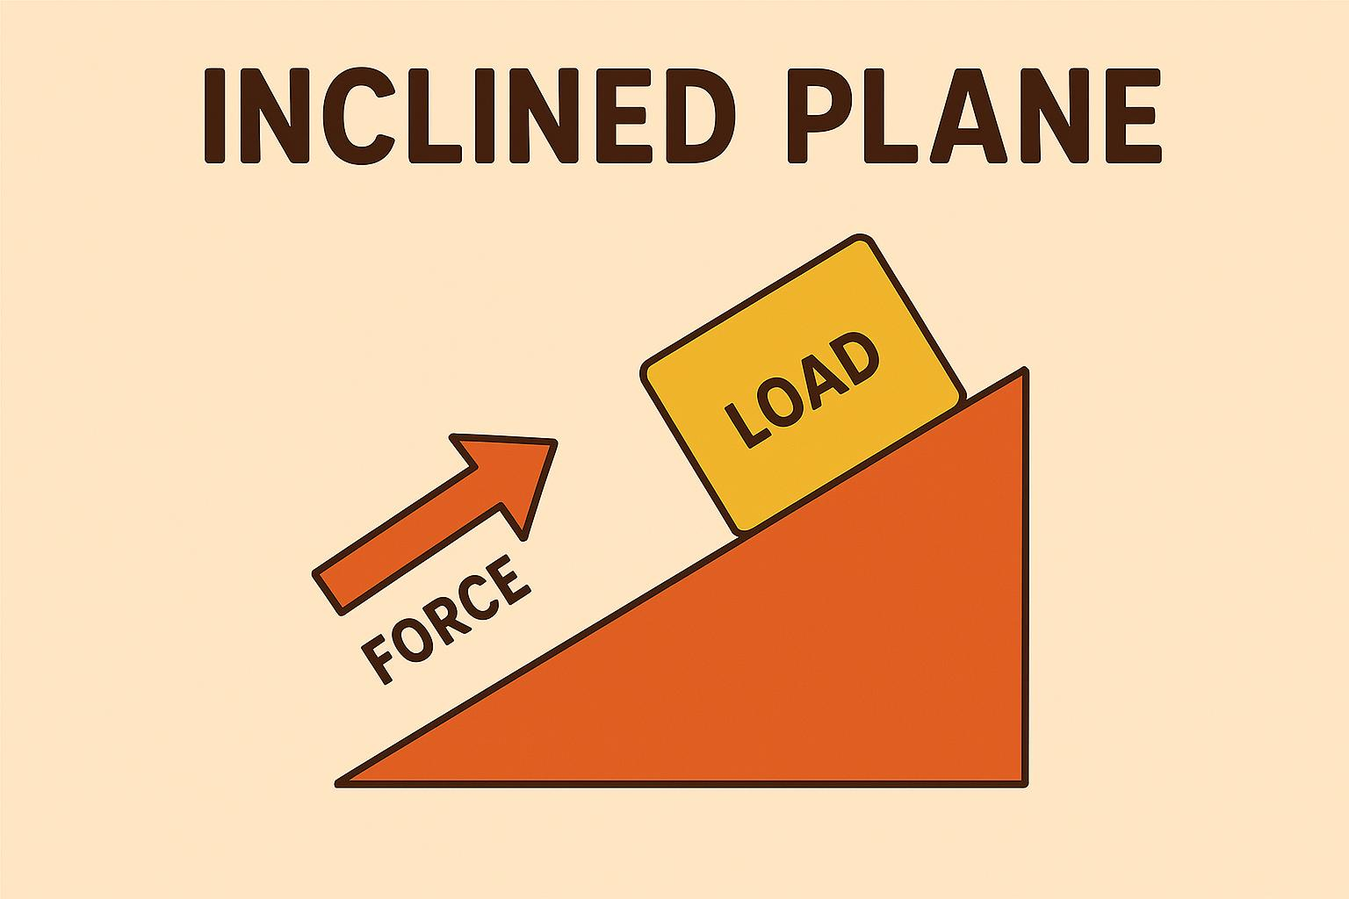
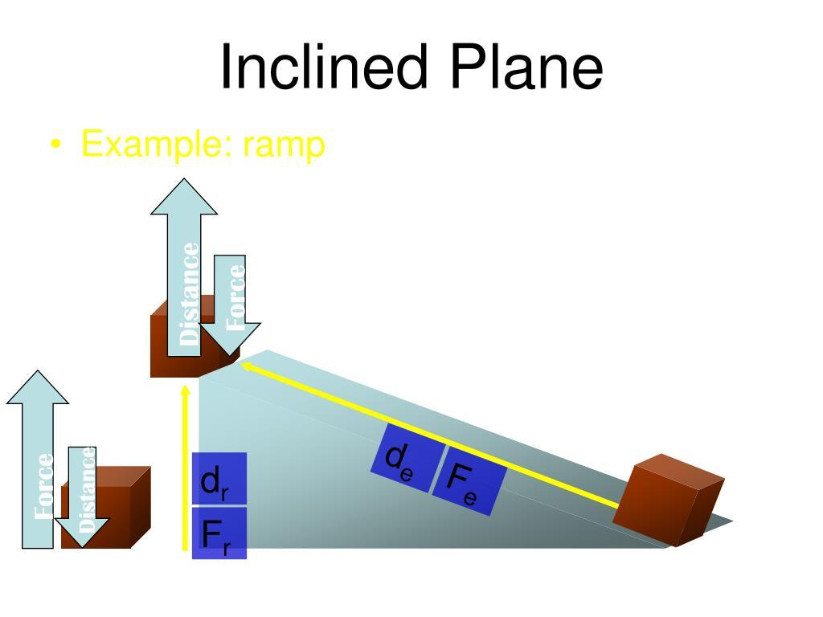
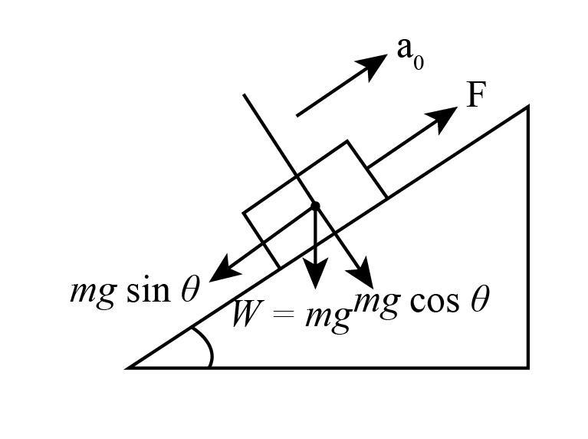
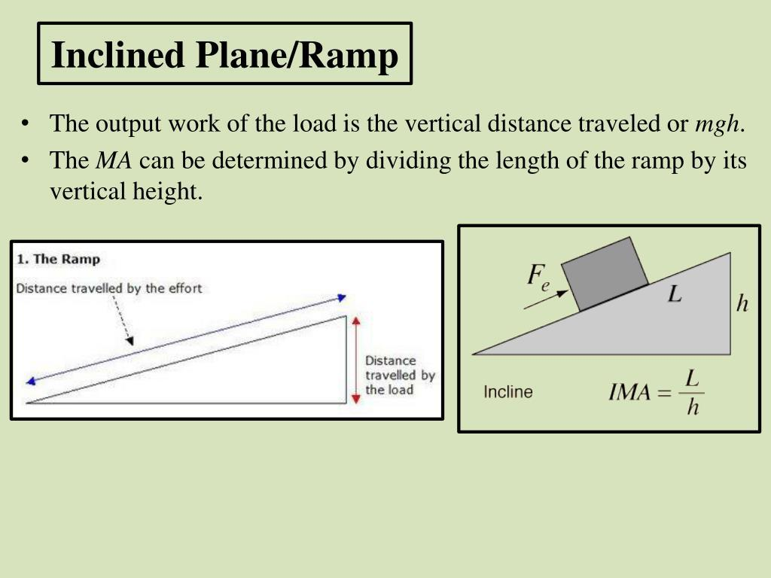
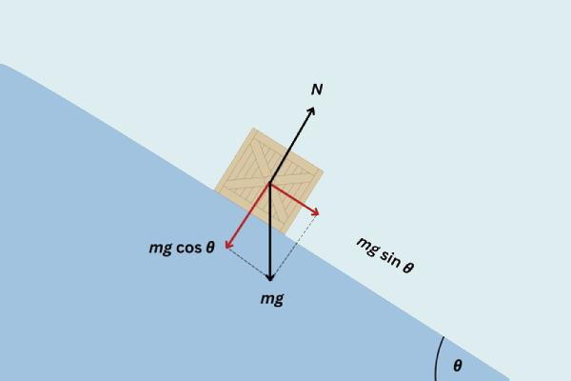
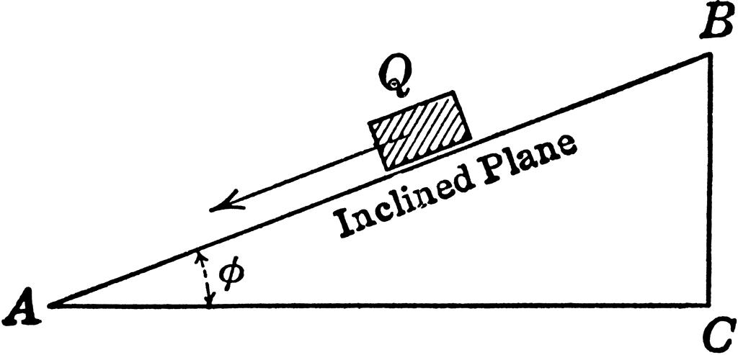

Definition
# Source: AI Source: Provided by: [Data Path: Persons Table -> ID Column: 1, Name_En Column: Motasem Essam] -> From: [ChatGPT] on [7/25/2026]
An Inclined Plane is a flat plane that forms an angle with the horizontal plane. Instead of being level like a horizontal plane or upright like a vertical plane, an inclined plane is sloped, allowing movement or measurement along a tilted surface.
In mathematics, an inclined plane is a geometric plane whose orientation is not parallel to the horizontal plane.
In physics, it is also recognized as one of the six classical simple machines, used to reduce the force required to raise or lower objects.

Characteristics
# Source: AI Source: Provided by: [Data Path: Persons Table -> ID Column: 1, Name_En Column: Motasem Essam] -> From: [ChatGPT] on [7/25/2026]
An inclined plane:
- Is flat and extends infinitely in geometry.
- Forms a nonzero angle with the horizontal plane.
- Is neither horizontal nor vertical.
- Can have any angle of inclination between:
$$0^{∘}<θ<{90}^{∘}$$
- Changes the direction of motion or force acting on an object.
- Has a constant slope if perfectly planar.

Illustration
# Source: AI Source: Provided by: [Data Path: Persons Table -> ID Column: 1, Name_En Column: Motasem Essam] -> From: [ChatGPT] on [7/25/2026]
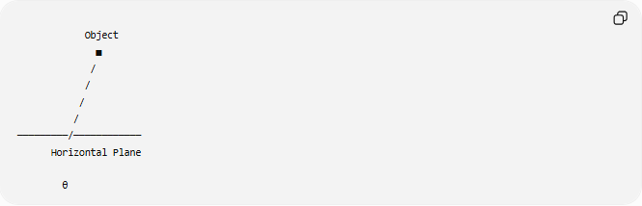
Object
■
/
/
/
/
─────────/────────────
Horizontal Plane

θ
The angle:
$$θ$$
is the angle of inclination measured from the horizontal plane.

Mathematical Representation
# Source: AI Source: Provided by: [Data Path: Persons Table -> ID Column: 1, Name_En Column: Motasem Essam] -> From: [ChatGPT] on [7/25/2026]
An inclined plane may be represented by the general plane equation:
$$Ax+By+Cz+D=0$$
When the plane is tilted relative to the horizontal, it cannot be simplified to:
$$z=c$$
Instead, its height changes with position.

Angle of Inclination
# Source: AI Source: Provided by: [Data Path: Persons Table -> ID Column: 1, Name_En Column: Motasem Essam] -> From: [ChatGPT] on [7/25/2026]
The inclination angle is measured between:
- The inclined plane.
- The horizontal plane.
Examples:
$${15}^{∘} \\ {30}^{∘} \\ {45}^{∘} \\ {60}^{∘}$$

Inclined Plane in Coordinate Geometry
# Source: AI Source: Provided by: [Data Path: Persons Table -> ID Column: 1, Name_En Column: Motasem Essam] -> From: [ChatGPT] on [7/25/2026]
Unlike the horizontal plane:
$$z=c$$
an inclined plane may have equations such as:
$$x+y+z=6$$
or
$$2x-y+3z=12$$
where the height changes continuously across the plane.

Inclined Plane in Physics
# Source: AI Source: Provided by: [Data Path: Persons Table -> ID Column: 1, Name_En Column: Motasem Essam] -> From: [ChatGPT] on [7/25/2026]
An inclined plane changes how gravity acts on an object.
The object's weight:
$$mg$$
can be resolved into two components:
- Parallel to the plane:
$$mg\sin{θ}$$
- Perpendicular to the plane:
$$mg\cos{θ}$$
These components determine the object's motion and the normal force.

Motion on a Frictionless Inclined Plane
# Source: AI Source: Provided by: [Data Path: Persons Table -> ID Column: 1, Name_En Column: Motasem Essam] -> From: [ChatGPT] on [7/25/2026]
For an object sliding without friction:
$$a=g\sin{θ}$$
where:
- $a$ = acceleration
- $g$ = gravitational acceleration
- $θ$ = angle of inclination

Visualization
# Source: AI Source: Provided by: [Data Path: Persons Table -> ID Column: 1, Name_En Column: Motasem Essam] -> From: [ChatGPT] on [7/25/2026]
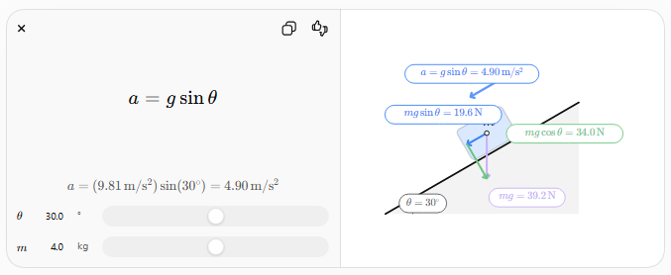

Examples
# Source: AI Source: Provided by: [Data Path: Persons Table -> ID Column: 1, Name_En Column: Motasem Essam] -> From: [ChatGPT] on [7/25/2026]
Example 1
An inclined plane makes an angle of:
$${30}^{∘}$$
with the horizontal.
It is therefore an inclined plane because:
$$0^{∘}<{30}^{∘}<{90}^{∘}$$

Example 2
A ramp rises:
- 2 meters vertically.
- 4 meters horizontally.
The plane is inclined because it has a measurable slope relative to the horizontal.

Real-World Examples
# Source: AI Source: Provided by: [Data Path: Persons Table -> ID Column: 1, Name_En Column: Motasem Essam] -> From: [ChatGPT] on [7/25/2026]
Inclined planes include:
- Ramps.
- Staircases.
- Sloped roads.
- Wheelchair access ramps.
- Roofs.
- Hillsides.
- Escalators.
- Slides.
- Conveyor belts.
- Mountain roads.

Applications
# Source: AI Source: Provided by: [Data Path: Persons Table -> ID Column: 1, Name_En Column: Motasem Essam] -> From: [ChatGPT] on [7/25/2026]
Inclined planes are used in:
- Plane Geometry
- Coordinate Geometry
- Physics
- Engineering
- Mechanical Engineering
- Civil Engineering
- Architecture
- Construction
- Surveying
- Robotics
- CAD (Computer-Aided Design)
- Transportation Design

Advantages
# Source: AI Source: Provided by: [Data Path: Persons Table -> ID Column: 1, Name_En Column: Motasem Essam] -> From: [ChatGPT] on [7/25/2026]
Inclined planes:
- Reduce the force required to lift objects.
- Make transportation easier.
- Provide smoother elevation changes.
- Simplify mechanical systems.
- Model sloped surfaces in mathematics and engineering.

Limitations
# Source: AI Source: Provided by: [Data Path: Persons Table -> ID Column: 1, Name_En Column: Motasem Essam] -> From: [ChatGPT] on [7/25/2026]
Inclined planes:
- Increase the distance traveled compared to vertical lifting.
- May introduce friction in practical applications.
- Require additional space compared to vertical movement.

Comparison with Other Plane Types
# Source: AI Source: Provided by: [Data Path: Persons Table -> ID Column: 1, Name_En Column: Motasem Essam] -> From: [ChatGPT] on [7/25/2026]
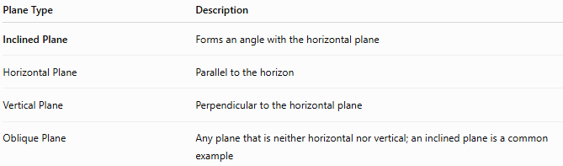
Plane Type | Description
Inclined Plane | Forms an angle with the horizontal plane
Horizontal Plane | Parallel to the horizon
Vertical Plane | Perpendicular to the horizontal plane
Oblique Plane | Any plane that is neither horizontal nor vertical; an inclined plane is a common example

Key Points
# Source: AI Source: Provided by: [Data Path: Persons Table -> ID Column: 1, Name_En Column: Motasem Essam] -> From: [ChatGPT] on [7/25/2026]
- An Inclined Plane is a flat surface tilted relative to the horizontal.
- Angle of inclination:
$$0^{∘}<θ<{90}^{∘}$$
- Weight components:
$$mg\sin{θ}$$
(parallel)
$$mg\cos{θ}$$
(perpendicular)
- On a frictionless plane:
$$a=g\sin{θ}$$
- It is one of the six classical simple machines.

Conclusion
# Source: AI Source: Provided by: [Data Path: Persons Table -> ID Column: 1, Name_En Column: Motasem Essam] -> From: [ChatGPT] on [7/25/2026]
An Inclined Plane is a flat surface that is tilted at an angle to the horizontal plane. In mathematics, it represents a sloped geometric plane, while in physics it serves as a simple machine that reduces the force needed to move objects by increasing the distance over which the force is applied. Inclined planes are fundamental in plane geometry, coordinate geometry, physics, engineering, architecture, construction, surveying, robotics, transportation design, and CAD, where they are used to model and analyze sloped surfaces, mechanical systems, and motion under gravity.

